DROPBOX 8.2: DAEDALUS AND ICARUS ASSIGNMENT
(35 points)
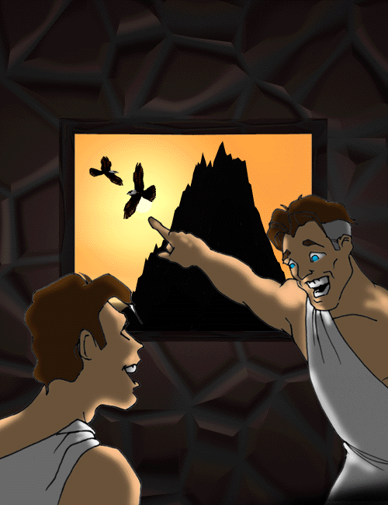

Goals: To apply knowledge of “Daedalus and Icarus” by writing a newscast and commercial. To learn persuasive devices and identify which ones are being used.

Everyone has watched a newscast before, right? Haven’t you secretly always wanted to be a newscaster? I know I have! Doesn’t it seem interesting and important to be the person responsible for giving news to the rest of the state, nation, or world? Now, you get your chance! You are going to create a newscast of the “Daedalus and Icarus” myth.

PART ONE: NEWSCAST (20 points)


You are going to write the script of your newscast and must have the following information. Certain things can be made up, but the majority of the facts you include must come directly from the myth (as well as introduction and analysis of it). It is up to you to decide how to word and arrange this information and anything else you want to include.

1-Your name (of course you may change it to sound more like a newscaster if you’d like… (Andrea Camberg instead of Andrea Camburn on Channel 10).
Nick Gallimore on Channel 3

2-The location and details of how the characters got where they are (Hint – use information from the analysis.)

Minos, a very powerful man had set Daedalus up by asking him to build an inescapable maze. Once it was built, Minos exiled them to the island where the maze was built.

3-An example of foreshadowing (a clue of something that is going to happen before it actually does)
Daedalus kisses his son on the forehead (not knowing this is a final goodbye).

4-What Daedalus and Icarus created and why

Daedalus and Icarus discovered a way to fly by using feathers and wax, a technology so advanced it made them appear as gods. This device was sure to reveal their fate, and it wasn’t what their attended goal of escaping the island.

5-What happened to Icarus
Icarus being the young boy that he was, flew too close to the sun and the wax melted on their machine. This caused to boy to plummet into the ocean and drowning.

6-The theme (message about life) to be learned by the myth
Your greatest creation, can become your most regretted.

7-A description of both Daedalus and Icarus
Daedalus was an “Artist famous in building” a very brilliant man. His son Icarus was a curious person, simply like every young boy, who doesn’t take things very seriously.

8-An explanation for why Daedalus may have “caused” this situation
Daedalus created the maze on the island, which ultimately was his greatest creation that used to trap him on the island.

*BE SURE TO USE THE “5 W’s” (who, what, where, when, why) and “1 H” (how), which are an easy way to check that you have the vital information.

Write your newscast here:

Hello and welcome to Channel Three News, my name is Nick Gallimore and were going to start today off with a quick look at a father and son who created their own demise.
Minos, the king of an Island called Crete had hired a man to create a Labyrinth on his island. This man’s name was Daedalus, an artist who was most famous for building. Daedalus soon constructed a maze that was so good; Minos entrapped him and his son Icarus on the island. Minos reason for doing this was to have his services forever. Daedalus being the inventive person that he is however had attempted many ways to escape the island. He soon had figured out a way fly, using feathers and wax. This creation was so advanced, that they appeared as gods to many. Due to his son’s foolishness, and playful personality, he would not listen to his father on how to properly fly. Daedalus tried to explain to his son that he could not fly high, as the sun would melt the wax on the feathers. Daedalus kissed his son (Good-bye, if he had known it) and they attempted to fly. Soon they were both over the ocean, Icarus however was flying too high and the sun had melted the wax on his feathers. This caused Icarus to plummet into the ocean, and he soon drowned. The lesson of this story is that even your greatest creation, can very well become your most regretted.

PART TWO: PERSUASIVE DEVICES AND COMMERCIAL (15 points)


So far in each of our myths, there has been some form of persuasion present. Isis convinces bands of children to search for Isis with her. Pyramus and Thisbe successfully persuade their parents to bury them together and the gods to turn the mulberry tree from white to red as a symbol of their experience. Daedalus appeals to Icarus not to fly too high to the sun, too low to the ocean and to follow him.

Now you get to have a little more fun with the myth by developing a persuasive commercial selling waxwings. Review the persuasive devices and complete the assignment below. Then, write your own commercial and be sure to use at least TWO persuasive devices. Label your devices!

Explanation and Examples of Persuasive Devices

Everyday, Americans are bombarded with advertisements and commercials. (Some would call this propaganda – information that is spread to support a cause) One statistic said that it is over 100 per day! Advertisers use persuasion to lure customers to new products. And guess what… you probably use persuasion everyday, too! Think about it…have you ever talked your way out of trouble? Convinced a friend to scrap homework and hang out? Persuaded your parents/ guardian to let you go somewhere or do something? Then you have used persuasion!

- Repetition – something repeated over and over. An example would be a commercial jingle or song. (Ex. Gimme a break, gimme a break…break me off a piece of KitKat bar.)
- Rhetorical Question – A question asked, but no answer is expected. It is to make you think! (Ex. an advertisement for a weight loss product asks you if you are tired being overweight. They really do not expect you to answer out loud!)
- Bandwagon – EVERYBODY is doing something. (Ex. You tell your parents/guardians that EVERYBODY is allowed to go on Spring break. Why can’t you? OR, commercials advertise that EVERYBODY is using this product and you should too!)
- Testimonial – a famous person endorses a product. (Ex. LeBron James drinks Sprite; Halle Berry wears Revlon).
- Transfer – Advertisers use something completely different to sell the product. (Ex. you are watching young, attractive people play beach volleyball and the ad is for cologne. The ad has nothing to do with the product, but you associate the good-looking people with the product.)
- Bait & Switch – You are lured in with one idea, but then it is not available and instead, something else is offered. (Ex. an ad says that a car is only $2000.00, but when you get there, it isn’t there and they try to sell you something more expensive. They have lured you in and then switch!)
- Glittering Generality – Positive words or phrases with a “feel-good” quality leave a nice impression without making any guarantee. (Ex. Snuggle fabric softener – who doesn’t want to believe that a cute teddy bear will do your laundry and your clothes will be extra soft and sweet-smelling? Does Snuggle probably work any better than anything else?)
- Plains folks – Allows you to relate to the person/ product. Gives a "folksy" feel. (Ex. Are you tired of creditors hassling you? I am too…that’s why I used this debt reduction service and it changed my life.)
- Card stacking – Ads giving only the positive side of a product or service, ignoring negative aspects. (Ex. Weight loss pills that will melt the fat away without you doing anything. Is it possible that the pills can have some other effect on you?)

Which persuasive device is being used? List the device below each statement or question. After you identify these eight devices, write your wax wings commercial in the box.

- An Olympic champion endorsing a product. (Testimonial)

- “Everybody who is anybody drives a Mercedes.” (Bandwagon)

- “Mr. Jones grew up right here in this town. You should vote for him.” (Plains Folks)

4. A boy does an amazing dance to a great rap song. You are drawn to the
commercial. At the end, you realize that he walks into McDonalds and the
advertisement is for McDonalds. (Transfer)

5. 1-800-SafeAuto, pick up the phone and call 1-800-SafeAuto…that’s 1-800-
Safe Auto! (Repetition)

6. “We’re out of the Nokia phone, but this Samsung one is better anyways.” (Bait and Switch)

7. “Are you ready to earn $4,000 a month without leaving your home?” (Rhetorical Question)

8. “This skin soap leaves your face clean, clear and fresh.” (Glittering Generality)

Write your commercial (with devices labeled) here!

There’s a reason the famous builder Daedalus used our product to fly. You can use our product to fly just like him! 1-800-Waxwings, pick up the phone and call 1-800-Waxwings! (Repetition, and Testimonial.)

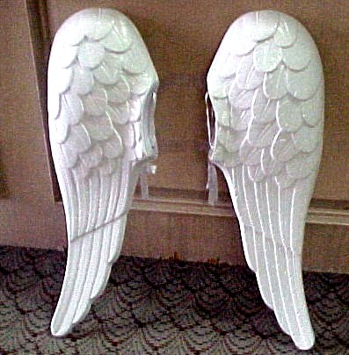
Self Check: Did you complete both parts of this assignment? Part 1 is the newscast, and Part 2 is filling out the persuasive devices AND writing the commercial. As always, feel free to call me for additional help.

Optional extra credit: Create a Power Point slide or scan in a sketch of your own to accompany either your newscast or commercial.

Preview time: What kind of myth would you write if you wrote your OWN? You can choose to
write a myth OR family story for our next assignment. Make it creative—I love to
read these! ☺

